**What is Ruby?**

Its Cross-platform (like Java)

Its Object oriented (also like Java 😊 )

Puts ‘hello world’ – basic program

Is an Interpreted language

Broadly similar to python

Indentation is irrelevant in Ruby

No default editor or IDE for ruby

Ruby is used for:

* Short scripts
* Automated tasks
* AI & NLP
* Websites (embed ruby into html)

A common implementation is Ruby on rails – uses a View Model Controller framework

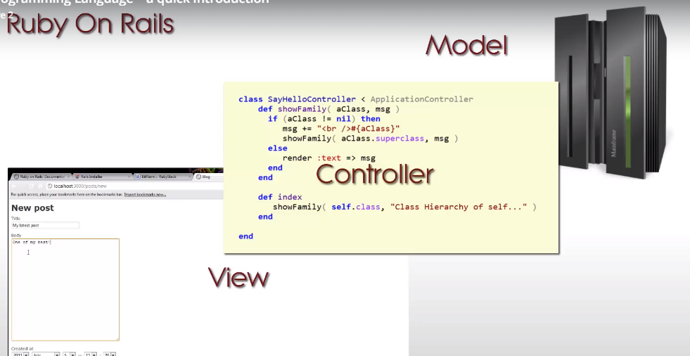

Installing for Windows via -> <http://rubyinstaller.org/>

Formatting Strings in Ruby

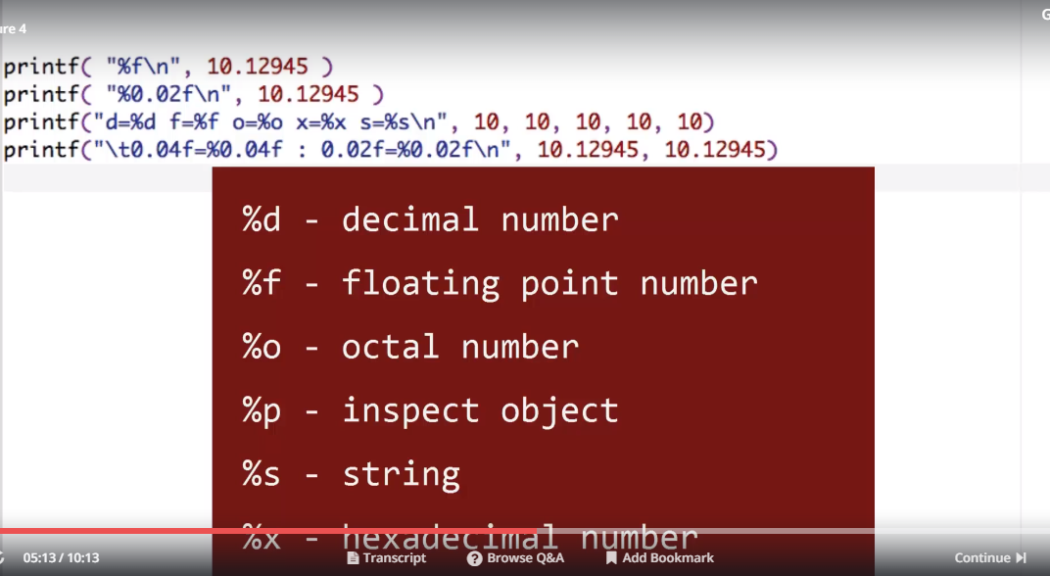

String methods found at this site

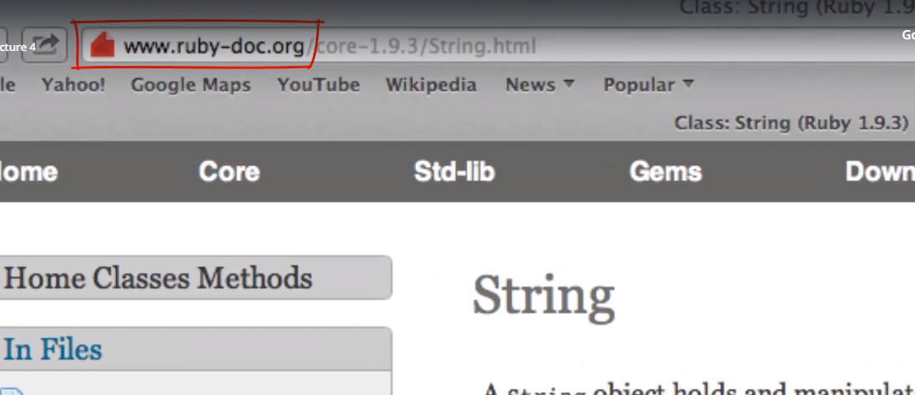

**Modules**

Can create an object or subclass from them

Useful for  
- wrapping functionality  
- mixins  
- allow to share common behaviour amongst several classes with a central point of control

**File Handling**

File mode opening options

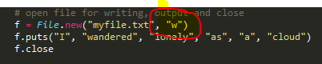

Options are as follows:

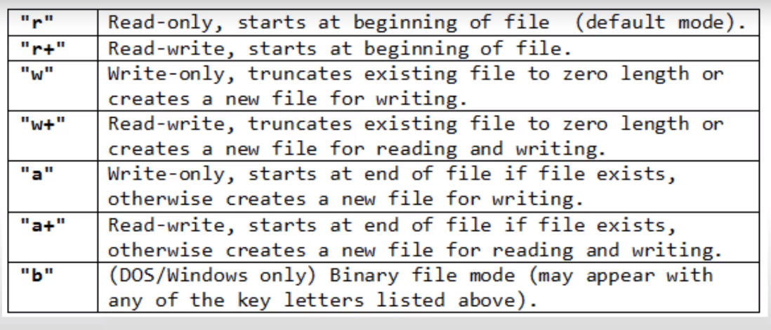

Open a file in write mode, puts statement writes each string to a **separate row** in the file, finally close will release file point and flush the buffer ot ensure all writes are committed into the file

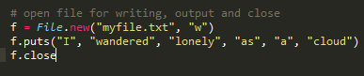

Listing to check for a files existence, check if file or directory

